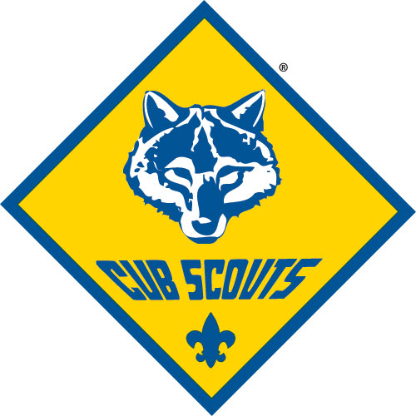
806
Cub Scout Pack 806 is part of the King Beaver District of the Moraine Trails Council. We are chartered through First United Methodist Church in Ellwood City. Our Pack is led by volunteers like you, who serve as Den Leaders, Committee members, and activity leaders.

Our overall objective is to provide a safe, FUN atmosphere where boys can grow while learning the core values of Scouting:
- Citizenship
ORIENTATION
GUIDE
- Compassion
- Cooperation
- Courage
- Faith
- Health and fitness
- Honesty
- Perseverance
- Positive attitude
- Resourcefulness
- Respect
- Responsibility

Den & Pack Meetings
Cub Scouting is a year-round family program designed for boys who are in the first grade through fifth grade (or 7, 8, 9, and 10 years of age). Cub Scouts join a Pack and are assigned to a Den based on their age: Tiger Cubs (1st graders), Wolf Cub Scouts (2nd graders), Bear Cub Scouts (3rd graders), and Webelos Scouts (4th and 5th graders). Dens typically meet weekly on Wednesday nights at 6:30PM at First United Methodist Church. Den leaders will let you know in advance when a meeting or activity will be held at an unusual date/time or location.

One meeting a month is designated as a Pack meeting, where all of the Dens and family members gather under the direction of the Cubmaster. Pack meetings are special times for food, fun, games, songs, skits, and other activities. Pack meetings are also where boys receive recognition of their achievements and advancements (badges, patches, etc.)

Uniforms
Cub Scouts and Leaders are encouraged to wear a “Class A” uniform to all Den and Pack activities. Uniform items can be rather pricey if purchased new (two local outlets for new items are the Council Service Center in Butler and the regional Scout Shop in Pittsburgh), but can often be found at consignment stores, on eBay, or in other inexpensive locations. The following items (in relative order of importance) make up the Scout uniform:
- blue Scout uniform shirt (your preference of long sleeve or short sleeve)
- Moraine Trails Council shoulder patch and Pack 806 numbers (we can order these for you once you obtain a uniform shirt – they’re about $10)
- Tiger/Wolf/Bear/Webelos neckerchief and slide (depending on age)
- Tiger/Wolf/Bear/Webelos hat

It is not necessary to purchase the uniform pants or shorts – blue jeans are fine. Also, a belt is useful. - - The Pack provides badges, pins, belt loops, and other advancement awards. These are paid for with Pack funds from our annual popcorn sale, which is typically our only fundraiser for the year.

Tiger Cubs can wear the orange Tiger t-shirt rather than buying the blue Scout uniform. (The boys grow so fast that if you buy the blue Scout uniform shirt when they are in 1st grade, then they are likely to outgrow it by the time they get to Webelos.) The orange Tiger t-shirts can be tough to find though, because they have been discontinued.

Pack Committee
The Pack Committee consists of the Committee Chair, Cubmaster, Den Leaders, representatives from the host organization, and other parents from the Pack. The Committee meets once a month to plan upcoming activities and to take care of Pack business. Attending a Pack Committee meeting is a good way for parents to begin getting more involved in the Pack or to just learn more about how Scouting works.

For More Information
Cubmaster: Joe Tweddell 724-462-4945 or weehawk42@gmail.com
Asst. to the Cubmaster: Ann Tweddell 724-622-5027 or anntweddell@gmail.com
Committee Chairman Doug Smith kylelevisdad@yahoo.com
Website: firstumcec.org/cubscouts

